7. Digital Beamforming

AIM:
To design and simulate a digital beamforming (DBF) system using MATLAB, generate the array factor of a uniform linear array (ULA), and analyze how digital weight control steers the beam in a desired direction.
TOOLS REQUIRED:
- MATLAB
- Communications Toolbox
- Signal Processing Toolbox
- Laptop/PC

THEORY:

Digital Beamforming (DBF) is a signal-processing technique used in antenna arrays to electronically control the direction of the transmitted or received beam. Unlike analog beamforming, DBF applies complex weights to the digitized signals from each antenna element, allowing flexible, adaptive, and multi-beam operation.
A Uniform Linear Array (ULA) consists of equally spaced antenna elements. When a plane wave arrives at an angle $θ$, the received signal has a phase shift between elements given by:
$$ϕ=2π\frac{d}{λ}sin⁡θ$$
where
- $d$= inter-element spacing
- $λ$= wavelength
The array factor (AF) for an N-element ULA with weights $w_{n}$is:
$$AF(θ)=∣\sum_{n=0}^{N-1}{w_{n}}e^{j2π\frac{d}{λ}nsin⁡θ}∣$$​n=0∑N−1​wn​ej2πλd​nsinθ
Principle of Digital Beam Steering
To steer the beam to an angle $θ_{0}$, weights are chosen as:
$$w_{n}=e^{-j2π\frac{d}{λ}nsin⁡θ_{0}}$$

PROCEDURE:

- Set the simulation parameters in MATLAB, including cell radius, number of tiers, bandwidth, spectral efficiency, and cluster size (K).
- Generate the hexagonal cell centers and plot the 7-cell hexagonal structure using the given radius.
- Apply frequency reuse by assigning colors to cells based on the reuse factor K.
- Randomly distribute users within the coverage region and assign each user to the nearest cell.
- Calculate coverage area, bandwidth per cell, capacity per cell, and users per cell based on simulation outputs.
- Plot the user distribution and capacity variation for different cluster sizes.
- Tabulate and record the results obtained from the simulation.

CODE:

% Digital Beamforming MATLAB Code
clear; clc; close all;
N = 8;
d = 0.5;
lambda = 1;
theta = -90:0.1:90;
theta_rad = deg2rad(theta);
theta0 = 20;
theta0_rad = deg2rad(theta0);
w = ones(N,1)/N;
AF = zeros(size(theta_rad));
for i = 1:length(theta_rad)
sum_val = 0;
for n = 0:N-1
phase = exp(1j*2*pi*(d/lambda)*n*sin(theta_rad(i)));
sum_val = sum_val + w(n+1)*phase;
end
AF(i) = abs(sum_val);
end
AF = AF/max(AF);
figure;
plot(theta,AF,'LineWidth',2);
xlabel('Angle (degrees)');
ylabel('Normalized AF');
title('Digital Beamforming Pattern');
grid on;
w_dbf = exp(1j*2*pi*(d/lambda)*(0:N-1)'*sin(theta0_rad));
w_dbf = w_dbf/sum(abs(w_dbf));
AF2 = zeros(size(theta_rad));
for i = 1:length(theta_rad)
sum_val = 0;
for n = 0:N-1
phase = exp(1j*2*pi*(d/lambda)*n*sin(theta_rad(i)));
sum_val = sum_val + w_dbf(n+1)*phase;
end
AF2(i) = abs(sum_val);
end
AF2 = AF2/max(AF2);
figure;
plot(theta,AF2,'r','LineWidth',2);
xlabel('Angle (degrees)');
ylabel('Normalized AF');
title('Steered Digital Beamforming Pattern (20°)');
grid on;
legend('DBF Output');
disp('Digital Beamforming Simulation Completed');
% End of Code
OUTPUT:
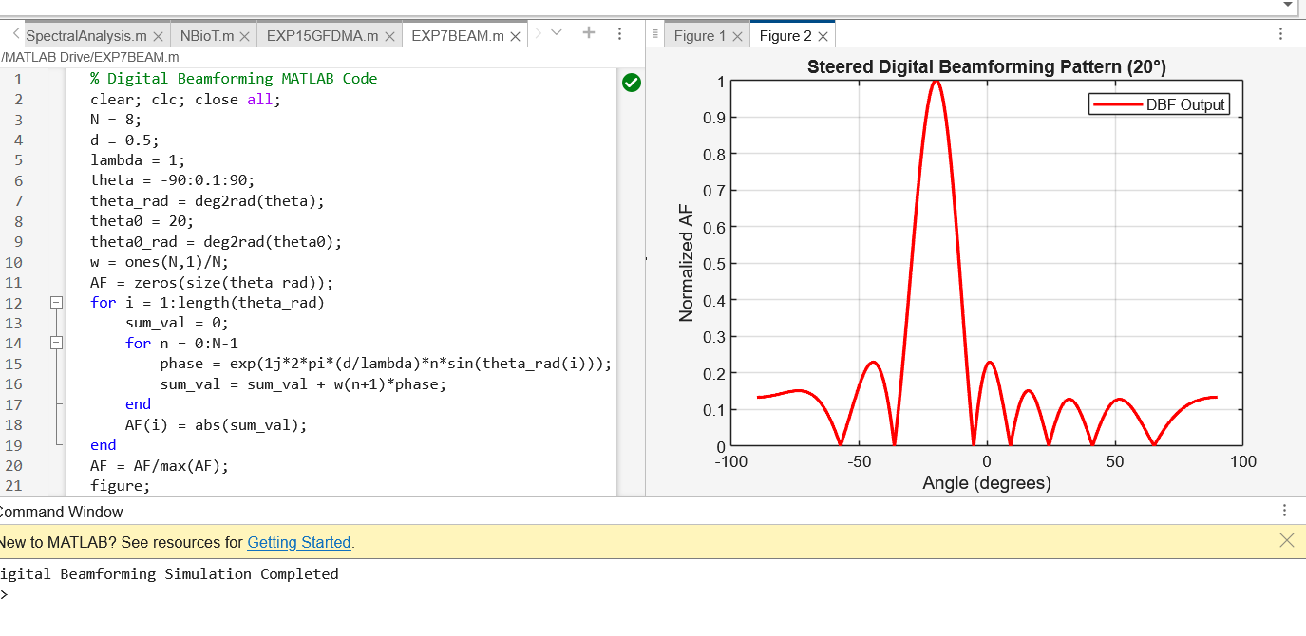
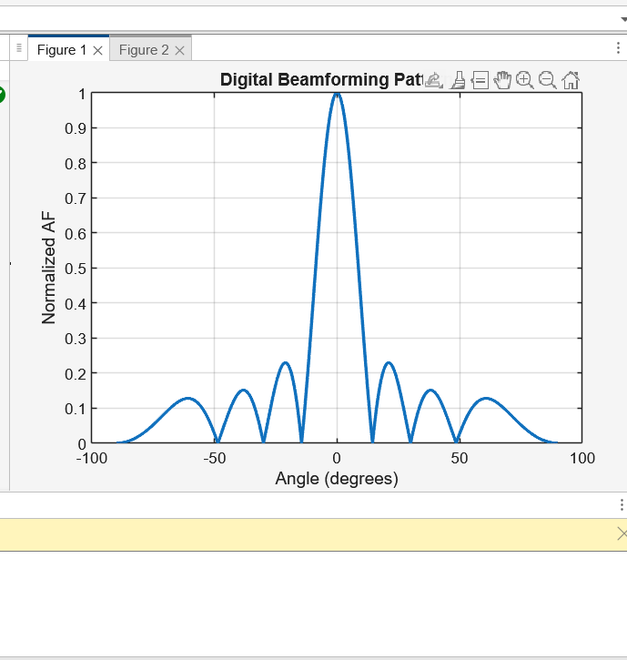

RESULT:
To design and simulate a digital beamforming (DBF) system using MATLAB, generate the array factor of a uniform linear array (ULA), and analyze how digital weight control steers the beam in a desired direction.

